Assignment 1: Basic Visualization for ggplot
Chad Huntebrinker
2025-08-24
## scatter plot practice
library(ggplot2)
##Load the data
data("mtcars")
df<-mtcars
#convert cyl as a groupin variable
df$cyl <- as.factor(df$cyl)
Figure 1:
#Figure 1
ggplot(df, aes(x=wt,y=mpg))+
geom_point(size = 8, position = "jitter", alpha = 1/5, color = "red") +
ggtitle("Car fuel consumption") +
xlab("Engine displacement (volume in liters)") +
ylab("Highway miles per gallon (MPG)")+
theme(plot.title = element_text(hjust = 0.5))
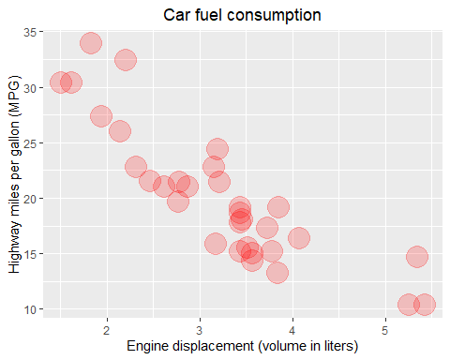
Figure 2:
#Figure 2
ggplot(df, aes(x=wt,y=mpg, color=factor(am)))+
geom_point(size = 8, position = "jitter", alpha = 0.2) +
ggtitle("Car fuel consumption") +
xlab("Engine displacement (volume in liters)") +
ylab("Highway miles per gallon (MPG)") +
theme(plot.title = element_text(hjust = 0.5)) +
scale_color_manual(
values = c("0" = "blue", "1" = "red"),
labels = c("Automatic", "Manual"),
name = "Transmission"
)
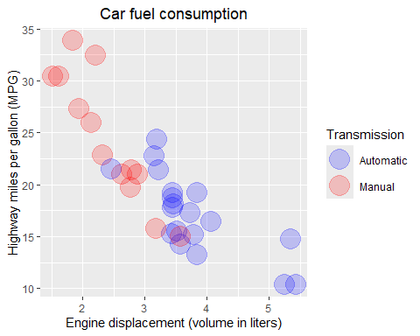
Figure 3:
#Figure 3
ggplot(df, aes(x=cyl,y=mpg, color="red"))+
geom_point(size = 7, alpha = 1/3) +
ggtitle("Car fuel consumption") +
xlab("Number of cylinders") +
ylab("Highway miles per gallon (MPG)") +
theme(plot.title = element_text(hjust = 0.5)) +
theme_bw()
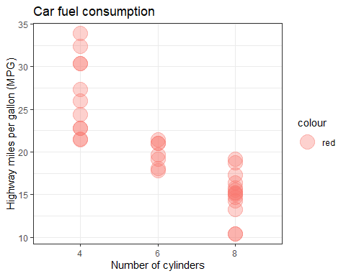
Figure 4:
#Figure 4
ggplot(mpg, aes(x=class,y=hwy, color="red"))+
geom_point(size = 7, position = "nudge", alpha = 1/3) +
ggtitle("Car fuel consumption") +
xlab("Car type") +
ylab("Highway miles per gallon (MPG)") +
theme(plot.title = element_text(hjust = 0.5)) +
theme_minimal()
